**Q 1 Python**

import pandas as pd

def process_data():

# Do not alter this line.

biopics = pd.read_csv("biopics.csv", encoding='latin-1')

# Write your code here.

# drop duplicates

biopics = biopics.drop_duplicates()

# rename variable

biopics = biopics.rename(columns={"box_office" : "earnings"})

# Filter missing earnings

biopics = biopics[~biopics['earnings'].isna()]

# keep only 1990 or later

biopics = biopics[biopics['year_release'] >= 1990]

biopics['type_of_subject'] = biopics['type_of_subject'].astype('category')

biopics['country'] = biopics['country'].astype('category')

# new variable

biopics.loc[biopics['lead_actor_actress'].isna() , 'lead_actor_actress_known'] = False

biopics['lead_actor_actress_known'] = biopics['lead_actor_actress_known'].fillna(True)

biopics['earnings'] = round(biopics['earnings']/1000000, 4)

biopics = biopics[["title", "year_release", "earnings", "country", "type_of_subject", "lead_actor_actress", "lead_actor_actress_known"]]

biopics = biopics.sort_values(by='earnings', ascending=False)

# Remember to return the right object.

return biopics.reset_index(drop=True)

process_data()

**Machine Learning**

import pandas as pd

data_train = pd.read_csv("data_train.csv")

data_test = pd.read_csv("data_test.csv")

import warnings

warnings.filterwarnings("ignore")

import pandas as pd

import numpy as np

from sklearn import linear_model

def regression(data_train, data_test):

alpha = np.logspace(-4, -1, 4)

Y = data_train['price'].values

X = data_train.drop(columns = ['price'])

ridge_model = linear_model.RidgeCV(alphas = alpha, normalize=True)

ridge_model.fit(X, Y)

ridge_best_alpha = ridge_model.alpha_

ridge_model = linear_model.Ridge(alpha = ridge_best_alpha, normalize=True)

ridge_model.fit(X, Y)

ridge_pred = ridge_model.predict(data_test.drop(columns=['price'])).round(2)

coef = ridge_model.coef_

columns = X.columns.values.reshape(-1, 1)

data = pd.DataFrame(data=columns, columns=['variable'])

data['coef'] = coef

ridge_data = data[abs(data['coef']) > 0.001]

del data

lasso_model = linear_model.LassoCV(alphas = alpha, normalize=True)

lasso_model.fit(X, Y)

lasso_best_alpha = lasso_model.alpha_

lasso_model = linear_model.Lasso(alpha = lasso_best_alpha, normalize=True)

lasso_model.fit(X, Y)

lasso_pred = lasso_model.predict(data_test.drop(columns=['price'])).round(2)

lasso_coef = lasso_model.coef_

columns = X.columns.values.reshape(-1, 1)

data = pd.DataFrame(data=columns, columns=['variable'])

data['coef'] = lasso_coef

lassoe_data = data[data['coef'] != 0]

del data

l1_ratio = np.arange(0.6, 1, 0.1)

elastic_model = linear_model.ElasticNetCV(alphas = alpha, normalize=True, l1_ratio=l1_ratio)

elastic_model.fit(X, Y)

elastic_best_alpha = elastic_model.alpha_

elastic_best_l1ration = elastic_model.l1_ratio_

elastic_model = linear_model.ElasticNet(alpha = elastic_best_alpha, normalize=True, l1_ratio=elastic_best_l1ration)

elastic_model.fit(X, Y)

elastic_pred = elastic_model.predict(data_test.drop(columns=['price'])).round(2)

elastic_coef = elastic_model.coef_

columns = X.columns.values.reshape(-1, 1)

data = pd.DataFrame(data=columns, columns=['variable'])

data['coef'] = elastic_coef

elastic_data = data[abs(data['coef']) > 0.001]

return {'ridge': {'alpha': ridge_best_alpha, 'pred': ridge_pred, 'coefficients': ridge_data},

'lasso': {'alpha': lasso_best_alpha, 'pred': lasso_pred, 'coefficients': lassoe_data},

'elastic_net': {'alpha': elastic_best_alpha, 'l1_ratio': elastic_best_l1ration, 'pred': elastic_pred, 'coefficients': elastic_data}

}

regression(data_train, data_test)

**SQL**

-- write your code in PostgreSQL 9.4

--SELECT user_id from logs where login_time > "2020-02-20 11:22:00";

SELECT user_id from logs where login_time > '2020-02-20 11:22:00' group by user_id  having(count(*)) >=1 order by user_id;

**And 10 technical Machine Learning MCQS**

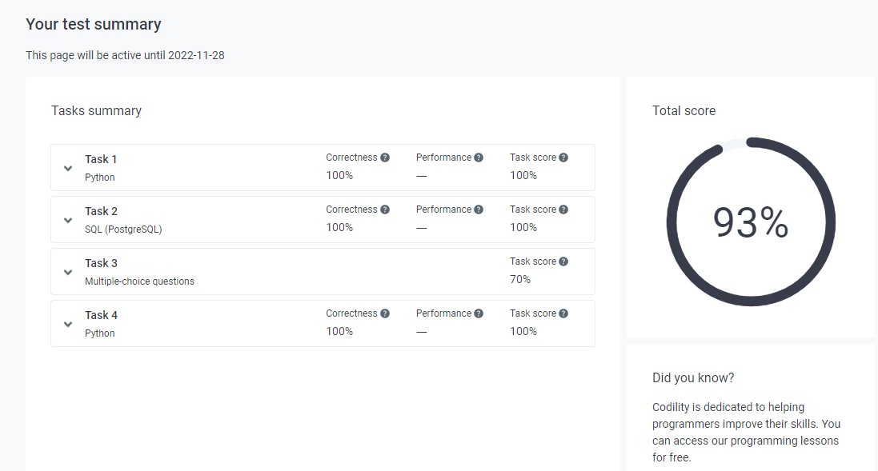

[**https://app.codility.com/c/feedback/J96SWM-T4E/**](https://app.codility.com/c/feedback/J96SWM-T4E/)

